9-60V 12-72V 40A 800W
Input Voltage Output Voltage Current Power
Key Features

• Wide range input voltage
• Design meeting RoHS / CE
• Maximum output power: 150W
• Maximum efficiency: 95%
• Support CAN or 485 bus communication function(Note2)
• Support input overvoltage protection
• Output short circuit limiting protection,
overtemperature protection,input voltage undervoltage protection
• Waterproof level IP65
• Voltage can be raised or lowered
• Filled with full glue,Natural air cooling
• Dual external fuse design for both input and output
• 2 Years warranty

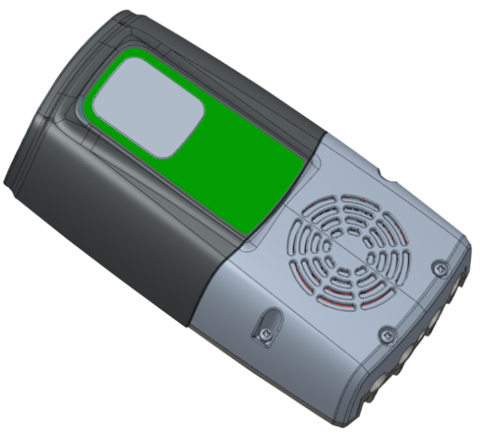

Usage Environment

• Industrial Automation Machineryxing
• In the field of new energy
• Industrial control system
• Energy storage charging system
• RV and ship control system
• Electronic instruments, equipment, and
devices

Description

EC-XXH151 is an efficient DC charger with a wide input voltage range that can provide stable output voltage. This charger has the advantages of small and beautiful size, good heat dissipation performance, and the open protocol supports intelligent control.

。

Model Description

This charger module has 485 or Can communication
for users to choose from. Users can interact with the charging module through a protocol, obtain basic information about the charging module, and set the module's UVP、OVP、OTP、Control module power on/off, etc.

Model Naming Method

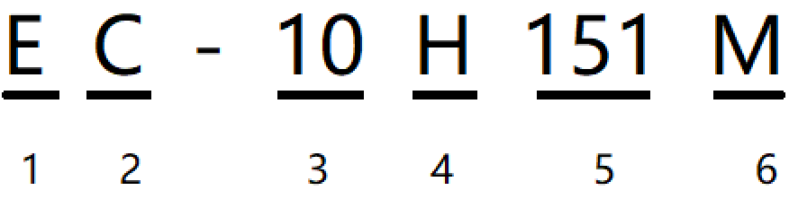

- E：”Enerchg”,company abbreviation
- C：charger,product type
- 3. 10：10A,Maximum continuous output current
- H:boost - buck
- 151：output max power，15 * = 150w
- M: shell material

Electrical specifications

Model No. |  |  | EC-10H151M | EC-05H151M
Output | Switching frequency |  | 100Khz | 100Khz
Output | Default Voltage |  | 14.6V | 29.2V
Output | Default Current |  | 10A±3%↓ | 5A±3%↓
Output | Default Power |  | 150W↓
Output | Voltage Charging Range |  | 10-15V | 16-30V
Output | Regulator accuracy(Typ.) |  | ±3% | ±3%
Output | Voltage regulation(Typ.) |  | ±2% | ±2%
Output | Load Regulation(Typ.) |  | ±1% | ±1%
Output | Output ripple and noise |  | 640mVp-p | 500mVp-p
Output | Output voltage rise time |  | 171ms | 171ms
Output | Boot delay time |  | 321ms | 321ms
Output | Output external capacitance |  | 4000μF | 3000μF
Output | Positive electrode cable |  | Suggestion: 20AWG Note5 | Suggestion: 22AWG Note5
Output | Negative electrode cable |  | Suggestion: 20AWG Note5 | Suggestion: 22AWG Note5
Output | Output fuse |  | 15A | 7.5A
Input | Efficiency Note3 | 12V | 95% | 95%
Input | Efficiency Note3 | 24V | 96% | 96%
Input | Voltage Range |  | 10-40Vdc
Input | Max. input voltage |  | 42V
Input | No-load power range |  | 1.0~1.5W
Input | Max. input current |  | 15A
Input | Input capacitance |  | 1320μF
Input | Positive electrode cable |  | Suggestion: 18AWG Note5
Input | Negative electrode cable |  | Suggestion: 18AWG Note5
Input | Input fuse |  | 20A
Protect | Input UVP |  | UVP:<9Vdc Recover:>9.5Vdc (Def.)
Protect | Input OVP |  | OVP:>43Vdc Recover:<42Vdc (Def.)
Protect | Overload protection |  | > 150W (Def.) Hiccup Mode
Protect | Output Short Circuit |  | Hiccup Mode
Protect | Over Temperature |  | 105℃Protect/ 95℃Recover (Def.)
Function | RS485 or CAN Communication Note4 |  | Set battery charging voltage, current, power, temperature, UVP and  OVP, LED full charge conversion point, report charging information and  faults. For details, please refer to RS485/CAN communication protocol
Function | LED light display |  | RED: battery is charging; GREEN： fully charged
Environment | operating temperature |  | -40~55℃
Environment | operating humidity |  | 5~90%
Environment | storage temperature |  | -55~100℃
 | Atmospheric pressure |  | 62~106Kpa
 | Altitude |  | 2000m
 | Cooling way |  | Natural cooling
Safety And EMC  Features | Anti-electric Strength |  | Input to Output | ≥1500Vdc
Safety And EMC  Features |  |  | Input to Shell | ≥1500Vdc
Safety And EMC  Features |  |  | Output to Shell | ≥500Vdc
Safety And EMC  Features | Insulation resistance |  | Input to Output | ≥10MΩ
Safety And EMC  Features |  |  | Input to Shell | ≥10MΩ
Safety And EMC  Features |  |  | Output to Shell | ≥10MΩ
Other | MTBF |  | ≥100,000H
Other | Weight |  | ≤1kg
Other | Package |  | White Box
Other | Dimension |  | 140*65*25mm(L*W*H)
Other | Shell material |  | aluminum alloy and insulating plastic
Other | Casting material |  | UL 94V-0
Note | - Unless otherwise specified, all specification parameters are measured under the conditions of an input of 24V direct current (dc), rated load, and an ambient temperature of 25℃.For details, please refer to the "EC-XXH151 test report".  - It can be selected when purchasing. It doesn't support both CAN and 485.  - For details, please refer to the "efficiency curve".  - For details, please refer to the "EC-XXH151 protocol Specification".  - The recommended value of the wire is the minimum requirement. If the wire length exceeds 50 cm, please use a thicker wire.  ※Product Disclaimer:

Characteristic Curves （TA = 25℃ Vin = 24V）

 | Figure 1, Efficiency curve
 | 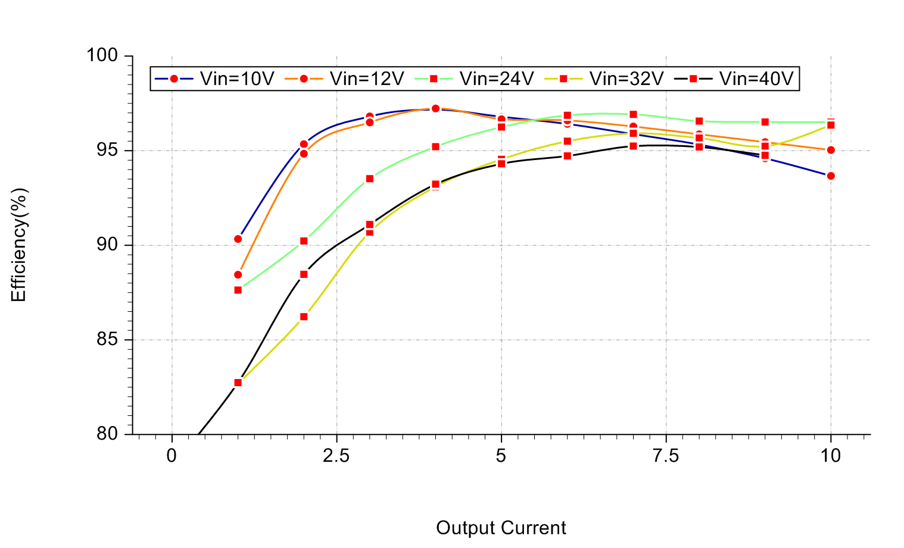
 | Vout=14.6V,Iout=10A | Vout=29.2V,Iout=5A
 | Figure 2, Power dissipation
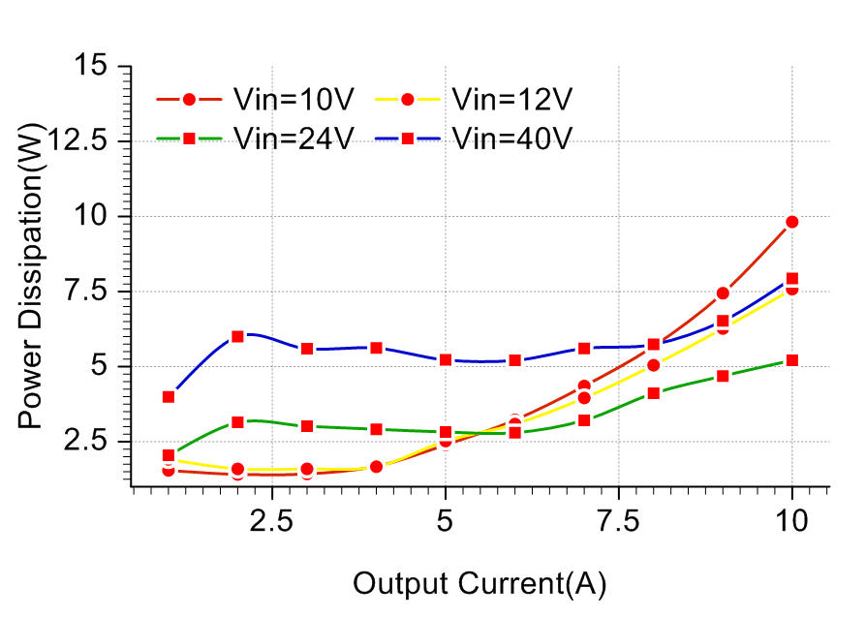
Vout=14.6V,Iout=10A |  | Vout=29.2V,Iout=5A
Figure 3, Input V-I
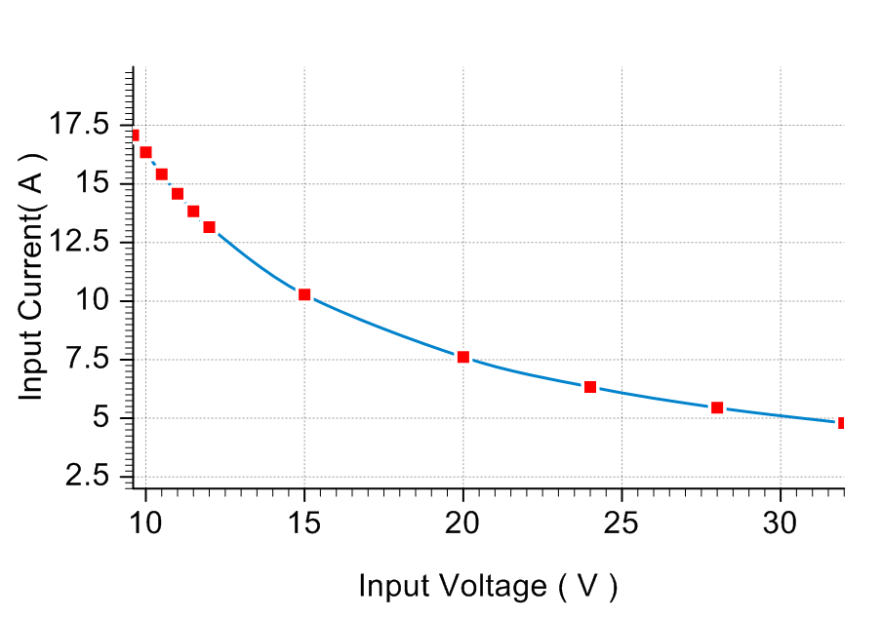
Vout=14.6V,Iout=10A |  | Vout=29.2V,Iout=5A

Typical Waveforms （TA = 25℃ Vin = 24V）

Figure 4, 50% - 75% load dynamic
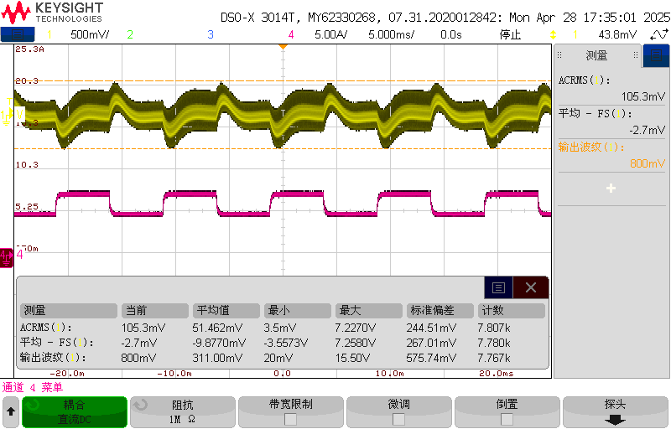
Vout=14.6V,load 50%-75%-50% | Vout=29.2V,load 50%-75%-50%
Figure 5, Output ripple & noise
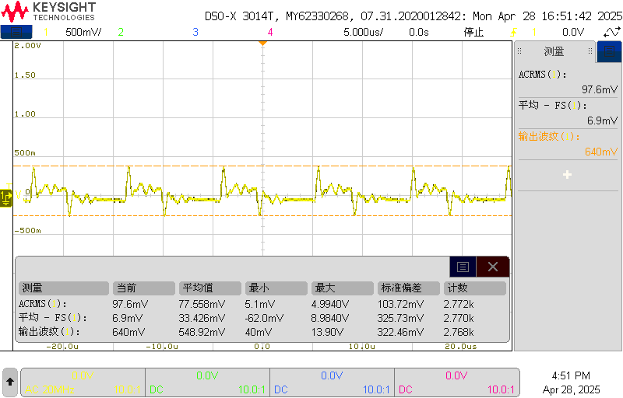
Vout=14.6V,Iout=10A | Vout=29.2V,Iout=5A
Figure 6, Output voltage established
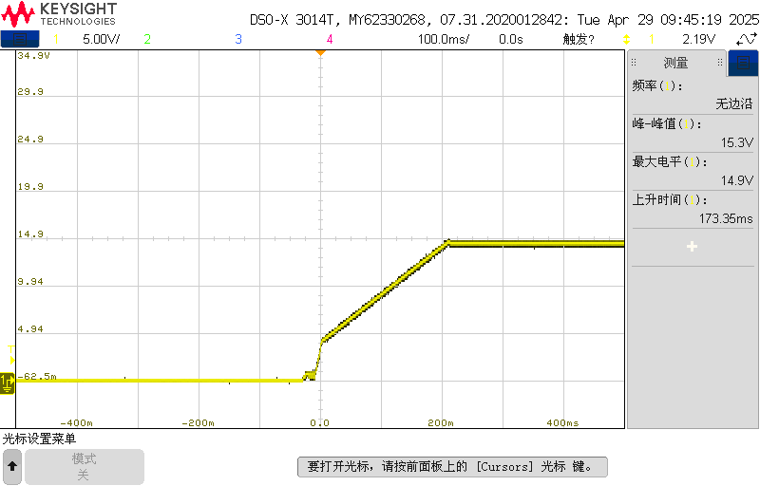
Vout=14.6V,Iout=10A | Vout=29.2V,Iout=5A
Figure 7, Boot delay time
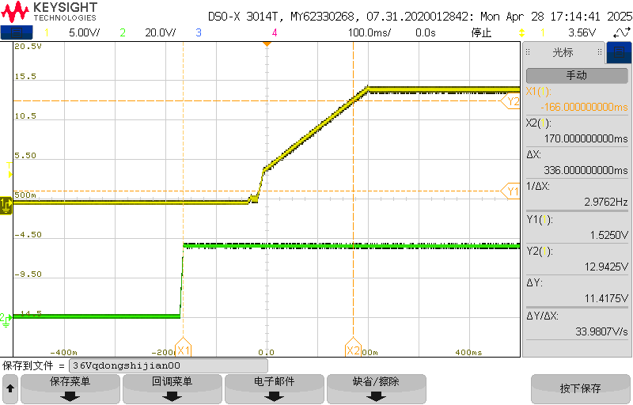
Vout=14.6V,Iout=10A | Vout=29.2V,Iout=5A
Figure 9, Short circuit & Out voltage

Feature Description

Input Under - Voltage Protection | Input Over - Voltage Protection
The converter will shut down after the input voltage drops below the under voltage protection threshold for shutdown. The converter will start to work again after the input voltage reaches the input under voltage protection threshold for startup. For the Hysteresis, see the Protection characteristics.
Overload protection | Output Short Circuit
 | A temperature sensor on the converter senses the average temperature of the module. It protects the converter from being damaged at high temperatures. When the temperature exceeds the over temperature protection threshold, the output will shut down. It will allow the converter to turn on again when the temperature of the sensed location falls by the value of Over temperature Protection Hysteresis
Over Temperature
A temperature sensor on the converter senses the average temperature of the module. It protects the converter from being damaged at high temperatures. When the temperature exceeds the over temperature protection threshold, the output will shut down. It will allow the converter to turn on again when the temperature of the sensed location falls by the value of Over temperature Protection Hysteresis

Thermal Consideration

Mechanical Diagram

